Gulf Coast

QUARTER 2 SPECIAL

Allergy awareness quarter at Gulf Coast will begin on April 1st and last until the end of June. April signals the arrival of Spring and thus allergy season. Even though it is allergy season all year around in Florida, we have decided to target in on these upcoming 3 months for our allergy awareness. During this time, we will be offering a 10% discount on selected allergy special products/ services. Please ask a staff member for more information or to see if your pets visit qualifies for the allergy awareness special.

Veterinary

Center

### Pet Food Formulation

April-June 2023

Skin allergies, called allergic dermatitis, are the most common type of allergic reactions in dogs. There are three main causes of skin allergies in dogs:

-Flea allergy dermatitis

-Food allergies

-Environmental allergens

Pet seasonal allergy symptoms to look for:  
Dogs and cats show similar allergy symptoms as humans, yet they experience them most through their skin. Excessive scratching likely means itchy, irritated skin. Here are a few more symptoms to watch out for:

-Scratching and biting their coat or skin

-Red, inflamed, or infected skin

-Excessive shedding

-Compulsive paw licking in dogs

-Boot scoots or licking their anal glands

-Chronic ear infections or red, waxy ears (common for dogs who are prone to ear problems in the first place)

-Respiratory issues, such as difficulty breathing, coughing, or wheezing (more common in cats)

Great news! Dr. Mathes has finished her food therapy course through the Chi Institute, and she’s ready to share this information with clients and patients!  We will now be offering to formulate homemade diets for your fur babies for an introductory rate!  We are looking forward to making healthier steps in 2023!!!

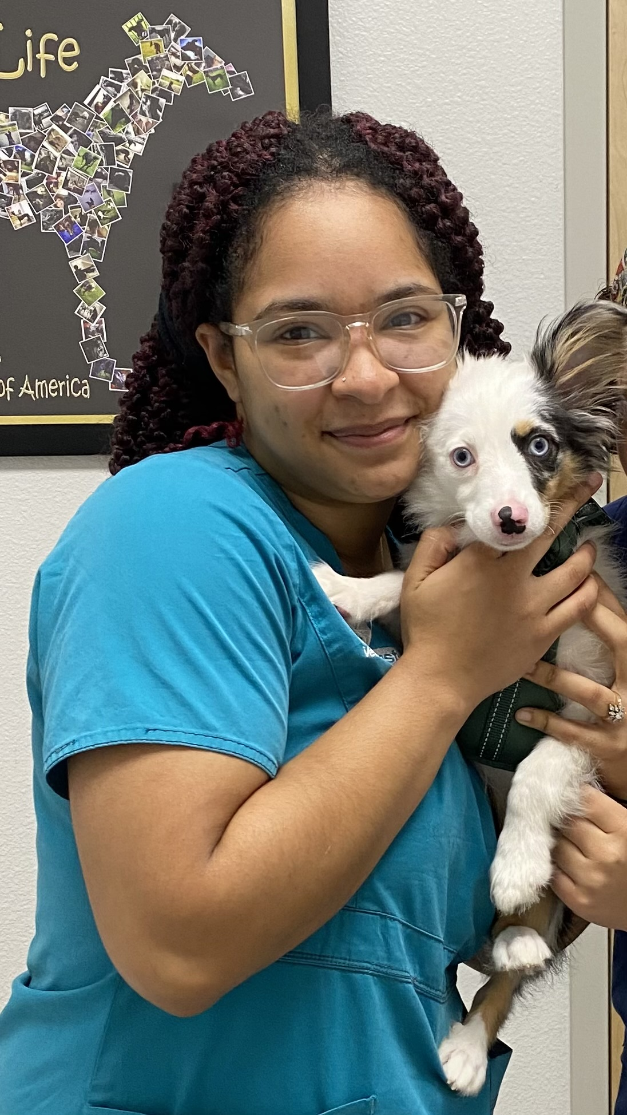

### PET TIPS FOR THE SPRING AND SUMMER MONTHS

We are bringing in the 2023 New Year quick, spring and summer are just around the corner. During these sunny and humid seasons there are many different things you can do to keep your pets happy and healthy.

Be sure to brush away at any mats and knots from your pets' fur. This can help circulation and regulate body temperature when outside.

Did you know if you have any hairless or short hair animals with white coat, they are more susceptible to getting sunburnt? You can use pet-safe sunscreen and lather it up in any of the exposed areas.

Always remember that cats and dogs do not sweat like us humans, so overheating can be a very serious concern once we get into high temperatures. You should never leave your pet in the car even for the smallest errands due to how quickly a vehicle in the sun can heat up.

Also, if you like to take your fur babies for daily strolls, you should start getting in the routine of taking them either early morning or in the evening hours once the sun goes down. This can help their body temperature remain normal and also keep their paws safe. Black asphalt attracts the suns UV rays and traps heat making the surface very hot and could potentially burn their paws. Also remember that having water on hand at all times or even ice cubes at home can be a good way to get your pet hydrated!

With summer flora in bloom in backyards and parks, be sure to always keep an eye on what your pet is eating. There are many common plants that are toxic to both cats and dogs. This in turn, attracts pests. If your pet is not on any prevention, we definitely suggest that you start them on a prevention. You can talk to any of our doctors about flea and tick meds that will be best for your pet!

](https://www.instagram.com/gulfcoastveterinarycenter/?hl=en)

PET OF THE QUARTER

EMPLOYEE OF THE QUARTER

Meet Cyber! Cyber is a 6 month old merle fluffy French bulldog! He is one of the few French bulldogs we see with such a fluffy soft coat. He has a few older and larger siblings at home that he enjoys being rowdy around the house with!

Meet Nicole! She is one of your Vet techs here at Gulf Coast. Her favorite part of the job is building that trusting bond between you and your fur babies. "Being able to put a smile on a owners face by making sure their baby is happy and healthy is such a rewarding feeling."

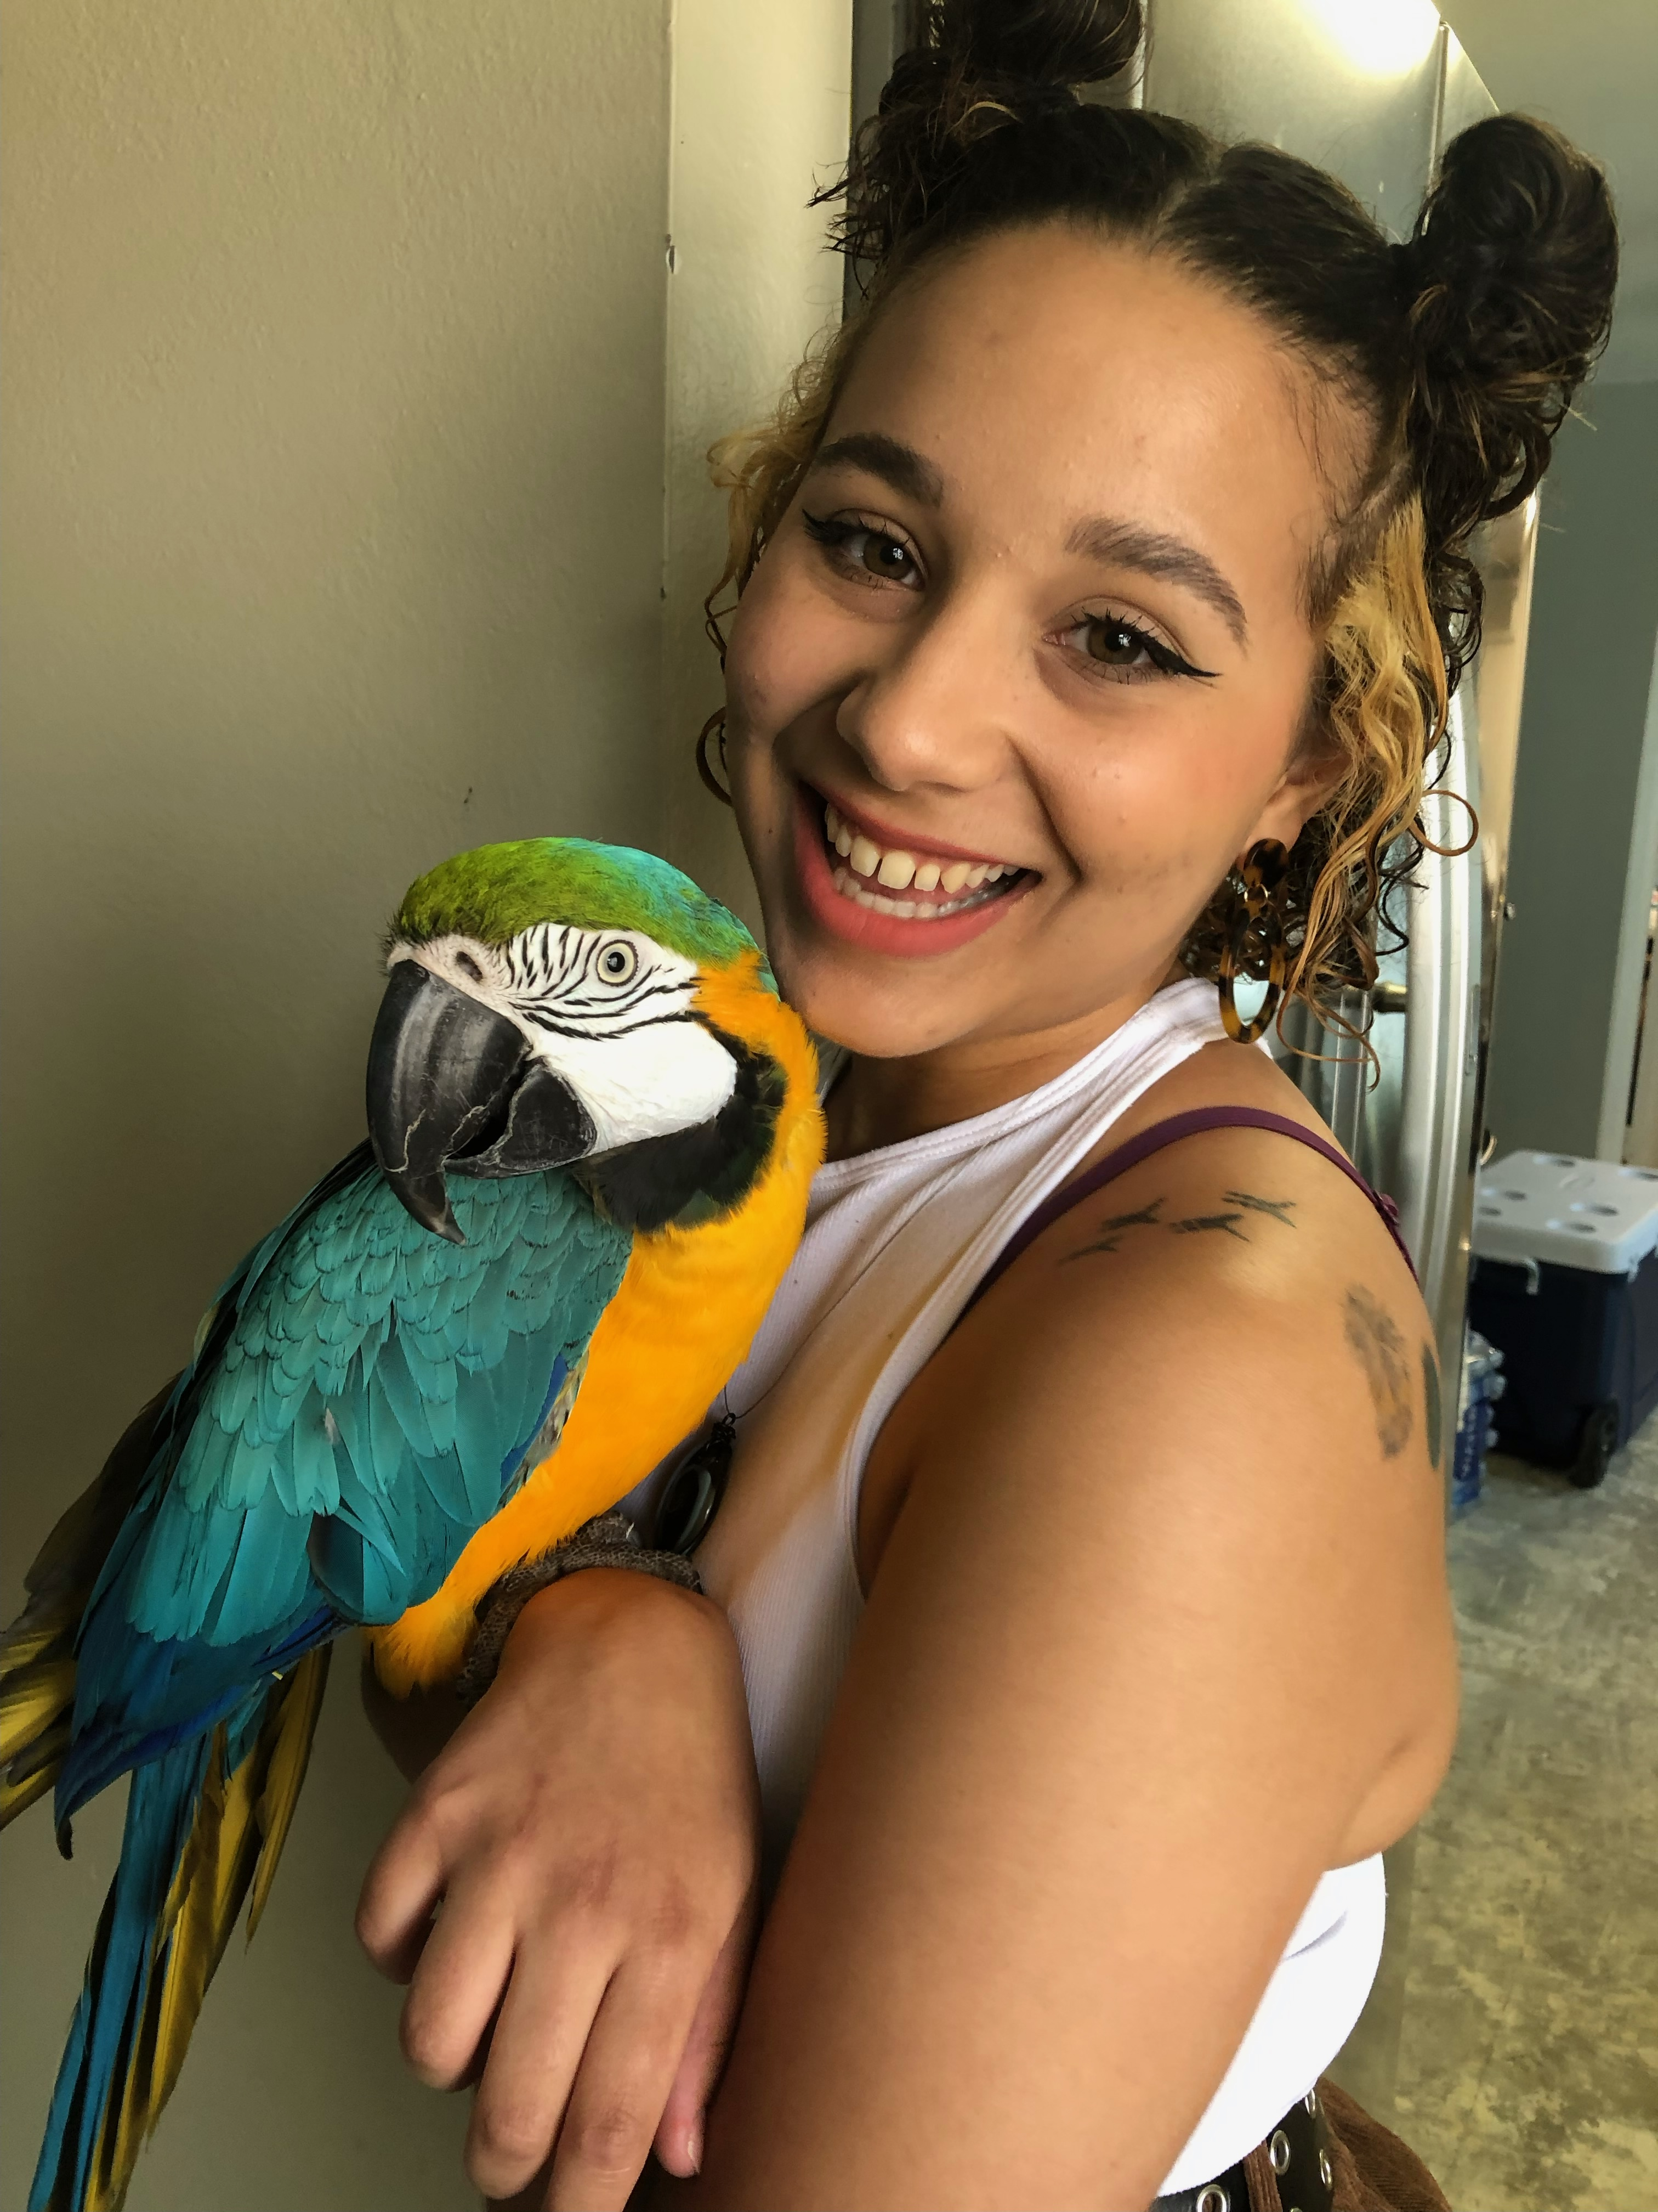

CONTACT US!

Linebaugh: (813)-746-3979

6902 Linebaugh Ave Tampa, FL 33625

[gcvcflorida@gmail.com](mailto:gcvcflorida@gmail.com)

www.gulfcoasttampa.com

Gunn Hwy: (813)-772-2311

6180 Gunn Highway Tampa, Fl 33625

Also please keep on the look out for our new Gunn Highway hours that will be changing here soon!!

STAFF RECOMMENDATIONS FOR THINGS TO DO WITH YOUR PETS!

Pups pub- Tampa Two Shepards Tap Room-Tampa

Dog bar- St. Pete Carrollwood Village Dog Park

Davis island- Dog beach Salt Shack on the bay Restaurant

Picnic Island- Dog Beach The river walk on Tampa Bay